Cat Scan II Big Dog

Executive Summary:

Cat is in charge of securing a business that uses a mix of Windows based systems. 1 Server, 1 Windows 10 Workstation and one KALI system.
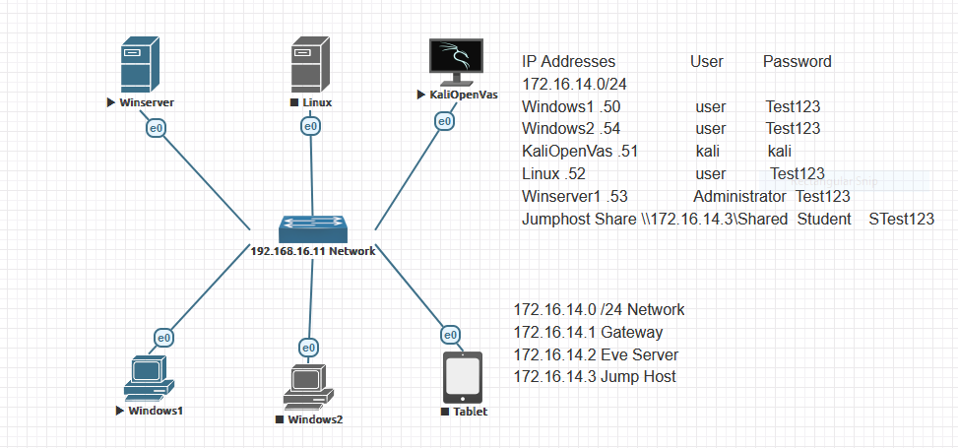

Additional information:
As one of the systems is a server, she wants to focus most of her attention there, but also remembering that the Windows Workstation and KALI system are used for development, and the Windows Server system has an SQL database that needs to be watched.
As you can see, the network consists of a Windows Server that runs an SQL database, as well as a website on IIS. This server also has PRTG on it and acts as a file server for the company.

Network Main Systems

Winserver

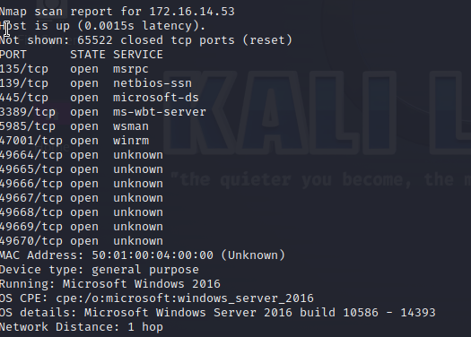
There are potential security vulnerabilities that need to be addressed by running an SQL database and a Web Host on the server. Some incidents such as unauthorized access, data breaches and SQL injections are among the risks that the server may face. If the server is not adequately protected, there is a higher risk of breaches. If an attacker gains unauthorized access to the server/website, they have the potential to steal, manipulate or destroy the data. Some performance issues may occur if there is too much traffic on the server either by malicious intent such as DDOS or by regular high traffic reasons on the website and database. Closely monitoring the server will significantly lower the risk of the above mentioned incidents. It is recommended to implement safeguards such as access controls, firewalls, encryption and regular audits. Lastly, separating the website and the SQL through virtualization can greatly minimize the risks.

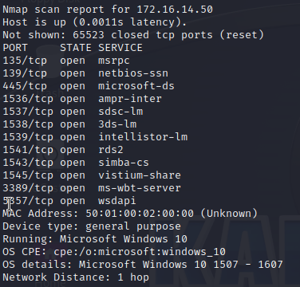
Windows1 Workstation
The windows devices may be susceptible to phishing attacks, data breaches and unauthorized privilege escalation. The fact that the marketing portion of the company is linked to those devices makes the company vulnerable to more social oriented threats (such as social engineering) more than any other component of the structure. Windows devices containing marketing related and management functions will be secured by regular updates. Strong and unique passwords, privilege restriction and regular audits.

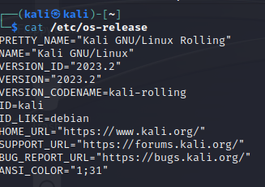
Kali:
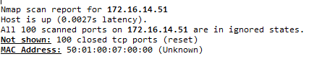
A Kali system containing valuable intellectual properties is susceptible for a Cyber attack that can lead to unauthorized access, data breach, denial of service attacks and ransomware (among other things). Restricting user privilege, encrypting the files and enabling firewalls to monitor ongoing and outgoing access would help minimize the risks.

CVE Vulnerabilities

Winserver Vulnerability
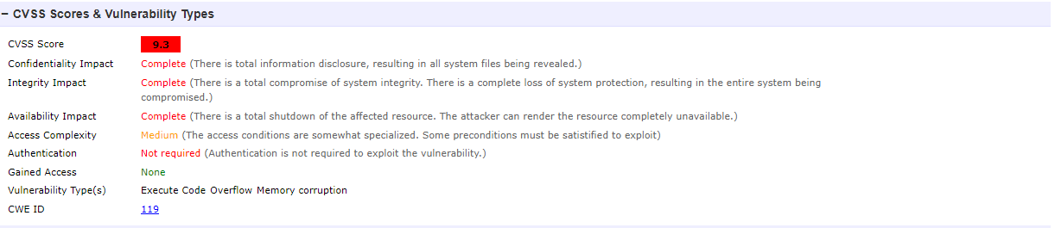
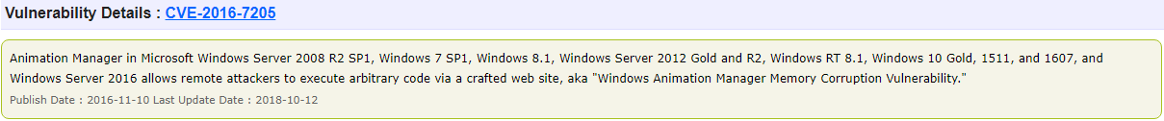
The LDAP sensor on PRTG could/ will require specific users authentication to access the server from a distance. Which would reduce the threat, but the medium access complexity require constant audit to limit the threat further.
Kali Vulnerability
No CVE vulnerability has been found on the latest Kali version. However, it does not mean that there is no vulnerability. It may mean that the version is too recent to find anything. Since the Kali device contains intellectual property, it is paramount to monitor it. The sensor “FTP server file count” will monitor any changes related to the targeted files in the database.

Windows Stations

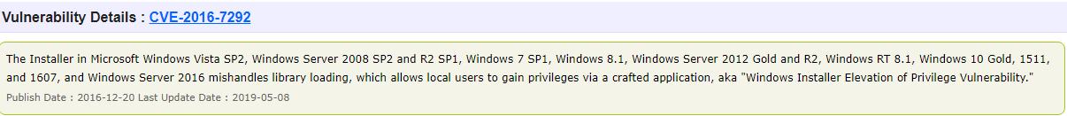
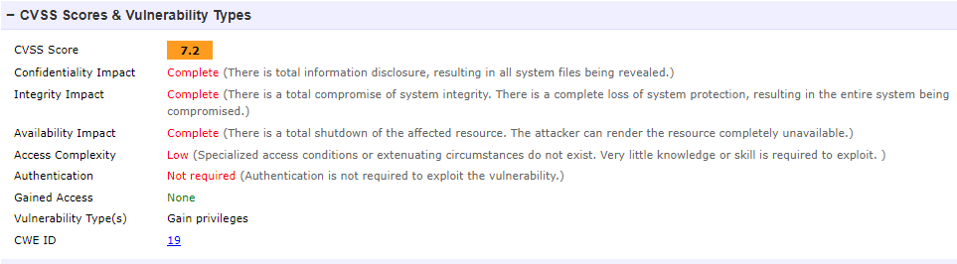
Monitoring important ports with PRTG as well as having the LDAP sensor (authentication) will limit the access to the system and will add a layer of complexity to any would be attacker.

Table of Devices and Sensors
Winserver | Linux | Windows
LDAP | LDAP | LDAP
MySQLv2
Port | Port | Port
SNMP traffic |  | SNMP Traffic
HTTP |  | HTTP
 | FTP Server File Count
SNMP CPU Load | SNMP CPU Load | SNMP CPU Load
VMI Security Center | VMI Security Center | VMI Security Center
SNMP Sonic Wall VPN Traffic | SNMP Sonic Wall VPN Traffic | SNMP Sonic Wall VPN Traffic

LDAP: Has two main goals: to store data in the LDAP directory and authenticate users to access the directory.
MySQL: Monitors the database and execute the appropriate requests (queries)
Port: Monitors the ports related to each devices to look for any reconnaissance scans
SNMP Traffic: Monitor the traffic on corresponding devices prevent DDOS attacks and monitor normal activity to prevent the overloading of the system.
HTTP: You can use this sensor to monitor if a website or a specific website element is reachable. It allows to the user to be at the forefront of a denial of service
SNMP CPU LOAD: Monitors how busy or burdened the computer or system is at a given time (good sensor to create/monitor a baseline)
VMI Security Center: It can monitor all security (firewalls) products that are controlled by Windows Security Center
SNMP Sonic Wall VPN Traffic: Ensures efficient operation of VPN connections and addresses network or security issues

Recommendations
Securing every component of the network is paramount to the company. However, more emphasis have been put on the server because it host the and the website. Segmentation which is to separate the database and the web server into different network zones would highly be recommended and is part of the industry best practices. I added an additional sensor from (SNMP Sonic Wall VPN Traffic) PRTG in case you would like to pursue that route. The Kali system contains intellectual property and must contain a file sensor to keep track of those who may manipulates them. Also, regular backup must be made on the Kali device as well as the Server. Lastly, the industry best practice forthe Windows devices, would be to implement access control with authentications because it is the portion of the company the most susceptible to social engineering and potential escalation of privilege.

